Research work

The fractal structure’s researching.
Modeling of the fractal sets in the Maple program.

The one who has performed: Ibragimova Evelina Ruslanovna
9th grade
Municipal Budget Educational Establishment “School # 57”
of Kirov district of Kazan

The one who has translated: A.V. Gibadullina

Scientific advisor – teacher of the highest category
A.I. Gibadullina

Kazan 2019
Table of contents:
Introduction .…………………………………………………………….....….. 3
I. Studying of principles of fractals construction …………...………….……... 4
II. Applied meaning of fractals……………………………….……….…….…. 8
III. Researching of computer programs of fractals construction …….……...... 12
Conclusion …..………………………………………………………….......... 15

Introduction
We don’t usually think about main point of things, which we have to do with every day. Environmental systems are many-sided, ever–changing and complicated, but they are formed by a little number of rules. Fractals are apt example of this – they are complicated, but based on simple regulations. Self – similarity is the main attribute of them. Just one fractal element contains genetically information about all system. This information have a forming role for all system. But sometimes self – similarity is partial.
Hypothesis of the research. Fractals and various elements of the Universe have general principles of structural organization. It is a reason why the theory of fractals is instrument for cognition of the world.
Purpose of the research. Studying of genetic analogy between fractals and alive and non-living Universe systems with computer-based mathematical modeling in the Mapel’s computer space.
Problems of the research.
- studying of principles of fractal’s construction;
- Detection of general fractal content of physical, biological and artificial systems;
- Researching of applied meaning of fractals;
- Searching of computer programs which can generate all of known fractals;
- Researching of fractals witch was assigned by complex variables;
- Formation of innovative ideas of using of fractals in different spaces;
The object of research. Fractal structures, nature and society objects.
The subject of research. Manifestation of fractality in different objects of the Universe.
Methods of the researching.
- Studying and analysis of literature of research’s problem;
- Searching of computer programs which can generate fractals and experimentation with them;
- Comparative analysis of principles of generating of fractals and structural organizations of physical, biological and artificial systems;
- Generation and formulation of innovation ways to applied significance of fractals.
Applied significance.
Researching of universality of fractals gives general academic way of cognition of nature and society.

I. Studying of principles of fractal construction
We can see fractal constructions everywhere – from crystals and different accumulations (clouds, rivers, mountains, stars etc.) to complex ecosystems and biological objects like fern leafs or human brain (table 3). Actually, the idea that fractal principles are genetic code of our Universe has been discussed for about fifteen years. The first attempt of modeling of the process of the Universe construction was done by A.D. Linde (table 1). We also know that young Andrey Saharov had solved “fractal” calculation problem – it was already half a century ago.
Now therefore, fractal picture of the world was intuitively anticipated by human genius and it inevitably manifested in its activity.
Table 1. A.D. Lind’s computer models
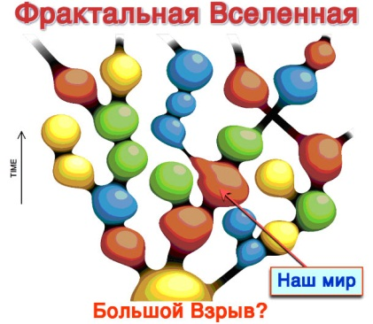  1. | 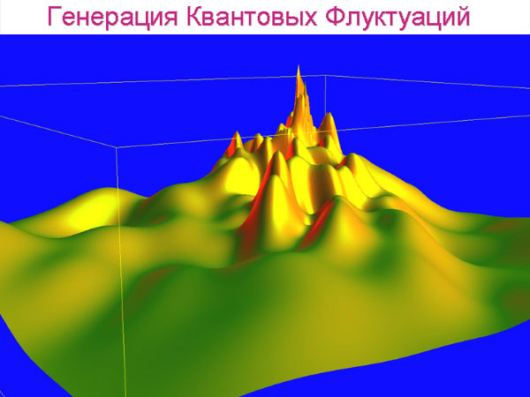  2.
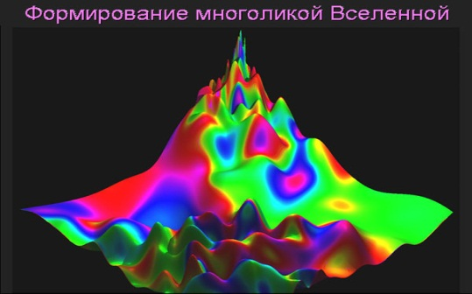  3. | 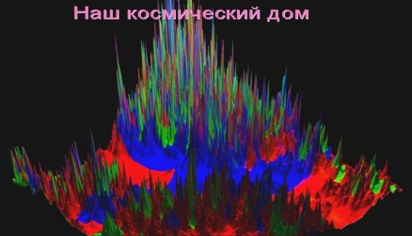  4.

Table 2. Google-maps
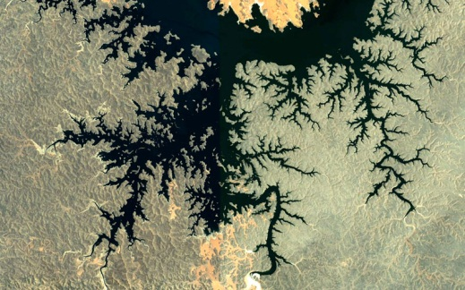  1. | 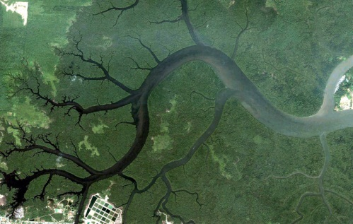  2.
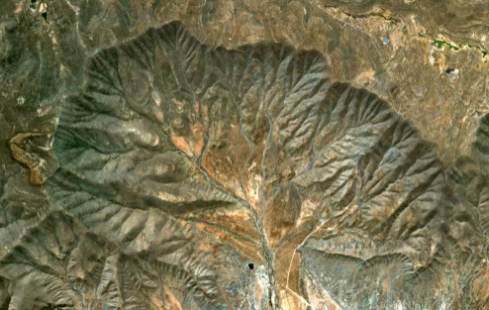  3. | 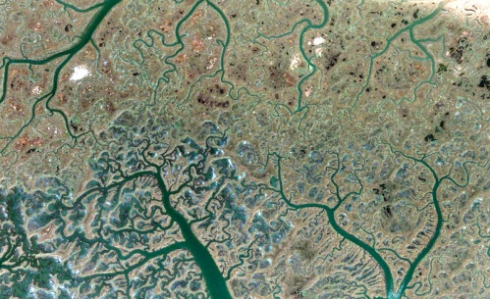  4.

Table 3. Nature fractals
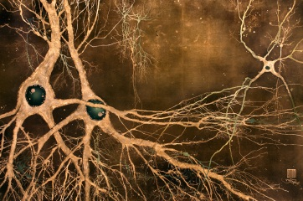  1. | 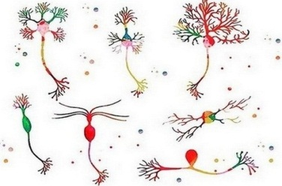  2. | 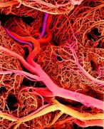  3.
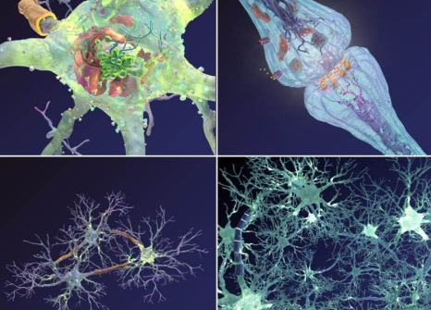  4. | 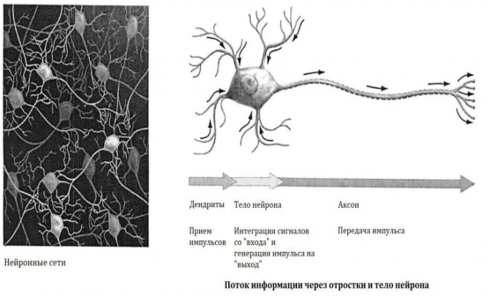  5.
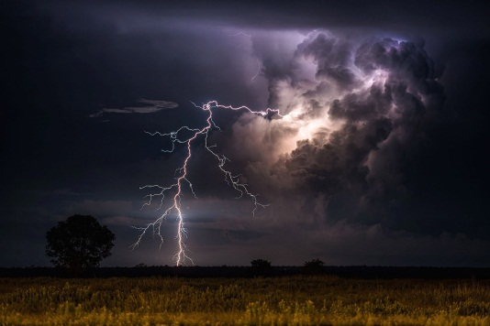  6. | 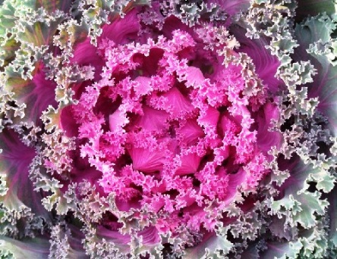  7.
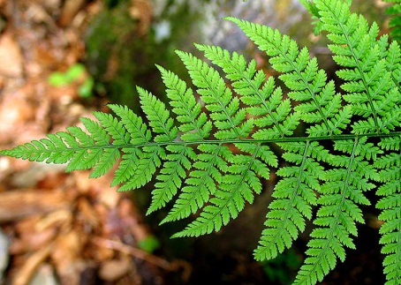  8. | 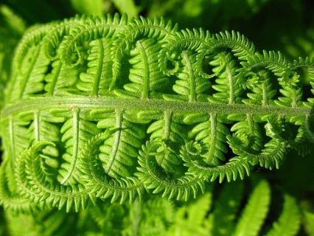  9.

Table 4. Fractal structures in the ancient architect constructions
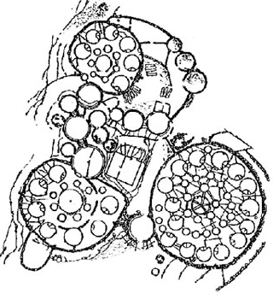  1. | 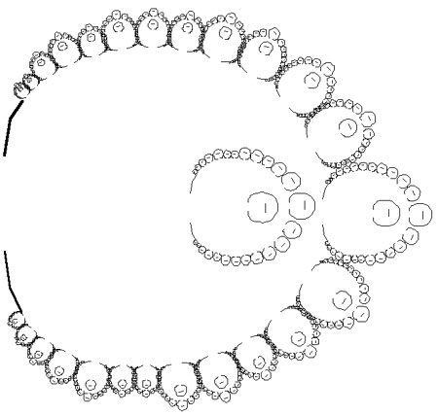  2. |  | 3.
Structures of african tribes’settelments
- Fragment of the gothic  stained glasses | 5. Kajuharo temple in the India |  | 6. Model of the Orthodox temple
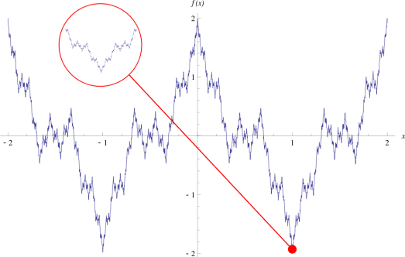  7. Veyershtrasse’s function |  | 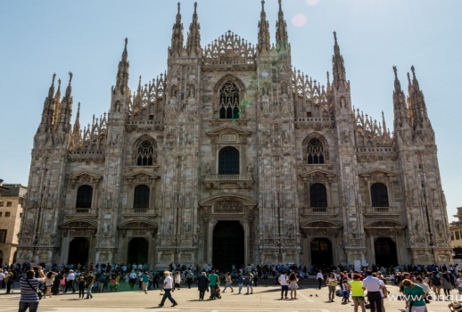  8. Gothic temple in the Milan

Fractals are divided into four groups in the traditional way: geometric (constructive), algebraical (dynamical), stochastical and natural.
The first group of fractals is geometric. It is the most demonstrative type of fractals, because we can instantly observe the self-similarity in it. This type of fractals is constructed in the basis of original figure by her fragmentation and realizing of different transformations. Geometrical fractals ensue on repeating of this procedure. They are using in computer-generated graphics for generating the pictures of leafs, bush, dimensional structures, etc.
The second large group of fractals - algebraical. This fractals are constructed by iteration of nonlinear displays, which set by simple formulas. There are two types of algebraical fractals – linear and nonlinear. The first of them are determined by first order equates (linear equates), and the second by nonlinear equates, their nature significantly brighter, richer and more diverse than first order equates.
The third known group of fractals – stochastical. It is generated by method of random modification of options in iterative process. Therefore, we get an objects which is similar to nature fractals – asymmetrical trees, rugged coasts, mountain scenery etc. Such fractals are useful in modeling of land topography, sea–surface and electrolysis process etc.
The fourth group of fractals is nature, they are dominate in our life. The main difference of such fractals is that they can’t demonstrate infinite self-similarity. There is “physical fractals” term in the classification concept for nature fractals, this term notes their naturalness. These fractals are created with two simple operations: copy and scaling. We can indefinitely list examples of nature fractals: human’s circulatory system, crowns and leafs of trees, lungs, etc. It is impossible to show all diversity of nature fractals.

II. Applied meaning of fractals
Fractals are having incredibly widespread application nowadays.
In the medicine. Human’s organism is consists from fractal structures (tab.3): circulatory system, bronchus, muscle, neuron system, etc. So it’s naturally that fractal algorithms are useful in the medicine. For example, assessment of rhythm of fractal dimension while electric diagrams analyzing allows to make more informative and accurate view on the beginning of specific illnesses. Also fractals are using for high–quality processing of X–ray images (in the experimental way). There are designing of new methods in the gastroenterology which allows to explore gastrointestinal tract organs qualitative and painlessly. Actually, there are discoveries of application of fractal methods for diagnosis and treatment of cancer.
In the science. There are no scientific and technical areas without fractal calculations nowadays. It happens due to the fact that majority of nature objects have fractal structures and dimension: coasts of the continents; natural resources allocation; magnetic field anomaly; dissemination of surges and vibrations in an elastic environments; porous, solid and fungal bodies; crystals; turbulence; dynamic of complicated systems in general, etc. Fractals are useful in geology, geophysics, in the oil sciences… It’s impossible to list all the spaces of adaptability.
Modeling of chaotic processes, particularly, in description of population models.
In telecommunications. It’s naturally that fractals are popular in this area too. Natan Coen is person, who had started to use fractal antennas. Fractal antenna has very compact form which provides high productivity. Due to this, such antennas are used in marine and air transport, in personal devises. The theory of fractal antennas has become an independent, well-developed apparatus of synthesis and analysis of electric small antenna (ESA) nowadays. There are developments of possibility of fractal compression of the traffic which is transmitted through the web. The goal of this is more effective transfer of information.
In the visual effects. The theory of fractals has penetrated area of formation of different kinds of visualizations and creation of special effects in the computer graphics soon. This theory are very useful in modeling of nature landscapes in computer games. The film industry also has not been without fractal geometry. All the special effects are based in fractal structure: mountain landscape, lava, flame, fog, large flows and the same. In the modern level of the cinema creation of the special effects is impossible without modeling of fractals.
In the economics. The Veirshtrass’s function is famous example of stochastic fractals. Analysis of graph of the function in interactive mathematic environment Maple allows to make sure in fractal structure of function by way of entry of different ranges of graphic visualization. In any indefinitely small area of the part graph of the function absolutely looks like area of this part in the all (table 4, pict. 7). The property of function is used in analysis of stock markets.
In the architect. Notably, fractal structures have become useful in the architect more earlier than B. Mandelbrode had discovered them. S.B. Pomorov, Doctor of Architecture, Professor, member of Russian Architect Union, talks about application of fractal theory in the architect in his article. Let’s see on the part of this article:
“Fractal structures were found in configuration of African tribal villages, in ancient Vavilon’s ziggurats, in iconic buildings of ancient India and China, in gothic temples of ancient Russia (table 4).
We can see the high fractal level in Malevich’s Architectons. But they were created long before emergence of the notion of fractals in the architect. People started to use fractal algorithms on the architect morphogenesis consciously after Mandelbrot’s publications. It was made possible to use fractal geometry for analyzing of architectural forms.
Fractals had become available to the majority of specialists due to the computerization. They had been incredibly attractive for architectors, designers and town planners in aesthetic, philosophical and psychological way. Fractal theory was perceived on emotional, sensual level in the first phase. The constant repression leading to loss of sensuality.
Application of fractal structures is effective on the microenvironment designing level: interior, household items and their elements. Fractal structures introduction allows creating a new surroundings for people with fractal properties on all levels. It corresponds to nesting spaces.
Fractal formations are not a panacea or a new era in the architect history. But it’s a new way to design architect forms which enriches the architectural theory and practice language. The understanding of nature fractal impacts on architectural view of urban environment. An attempt to develop the method of architectural designing which will base in an in-depth fractal forms is especially interesting. Will this method base only on mathematics? Will it be different methods and features symbiosis? The practice experiments and researches will show us. It’s safe to say that modern fractal approach can be useful not only for analysis, but also for harmonic order and nature’s chaos, architect which may be semantic dominant in nature and historic context.”
Computer systems. Fractal data compression is the most useful fractal application in the computer science. This kind of compression is based on the fact that it’s easy to describe the real world by fractal geometry. Nevertheless, pictures are compressed better than by other methods (like jpeg or gif). Another one advantage is that picture isn’t pixelateing while compressing. Often picture looks better after increase in fractal compressing.
Basic concept for fractal computer graphics is “Fractal triangle”. Also there are “Fractal figure”, “Fractal object”, “Fractal line”, “Fractal composition”, “Parent object” and “Heir object”. However, it should be noted that fractal computer graphics has recently received as a kind of computer graphics of 21th century.
The opportunities of fractal computer graphics cannot be overemphasized. It allows creating abstract compositions where we can realize a lot of moves: horizontal and vertical, diagonal directions, symmetry and asymmetry etc. Only a few programmers from all over the world know about fractal graphics today. To what can we compare fractal picture? For example, with complex structure of crystal or with snowflake, the elements of which line up in the one complex composition. This property of fractal object can be useful in ornament creating or designing of decorative composition. Algorithms of synthesis of fractal rates which allows to reproduce copy of any picture too close to the original are developed today.

III. Researching of computer programs of fractal construction
Strict algorithms of fractals are really good for programming. There are a lot of computer programs which introduce fractals nowadays. Computer mathematic systems are stand out from over programs, especially, Maple. Computer mathematics is mathematic modeling tool. So programming represents genetic structure of fractal in these systems and we can see precise submission of fractal structure in the picture while we enter a number of iterations (table 5). This is the reason why mathematic fractals should be studied with computer mathematics. The last discovery in fractal geometry has been made possible by powerful, modern computers. Fractal property researching is almost completely based on computer calculations. It allows making computer experiments which reproduce processes and phenomenon which we can’t experiment in the real world with.
Our school has been worked with computer mathematics Maple package more than 10 years. So we have unique opportunity to experiment with mathematic fractals, thanks to that we can understand how initial values impact on outcome (it is stochastic fractal). For example, we have understood the meaning of the fact that color is the fourth dimension: color changing leads to changing of physical characteristics. That is what astrophysics mean talking about “multicolored” of the Universe. While fractal constructing in interactive mathematic environment we received graphic models which was like A. D. Linde’s model of the Universe (table 1). Perhaps, it demonstrates that Universe has fractal structure.
Table 5
Menger’s sponge
i=0  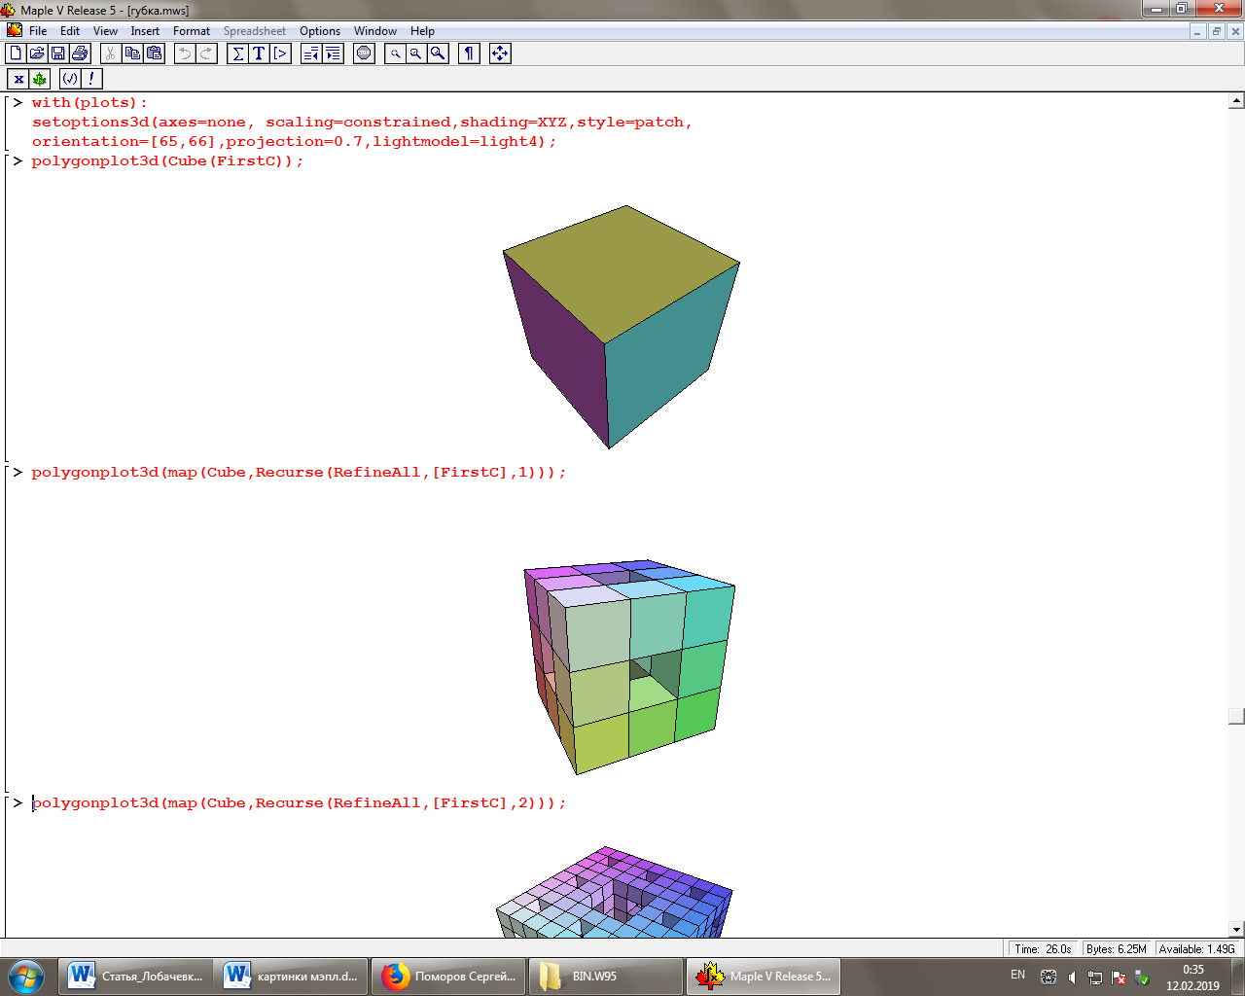 | i=1 |  |  | i=3  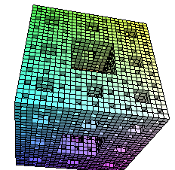
Lambda
For m from 0 to 10 while abs (z) < 3 do  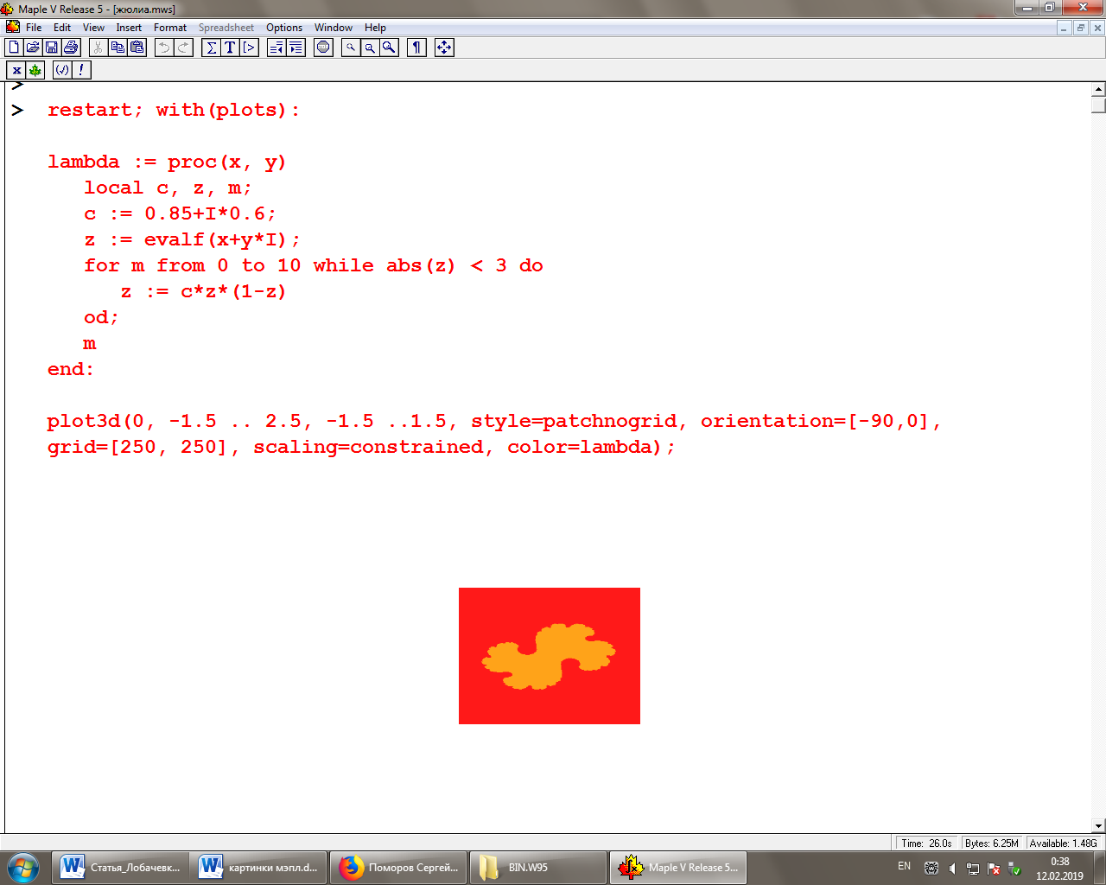 |  | For m from 0 to 30 while abs (z) < 1 do  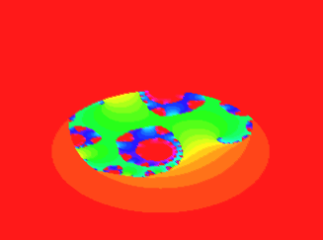 |  |  | 3-D  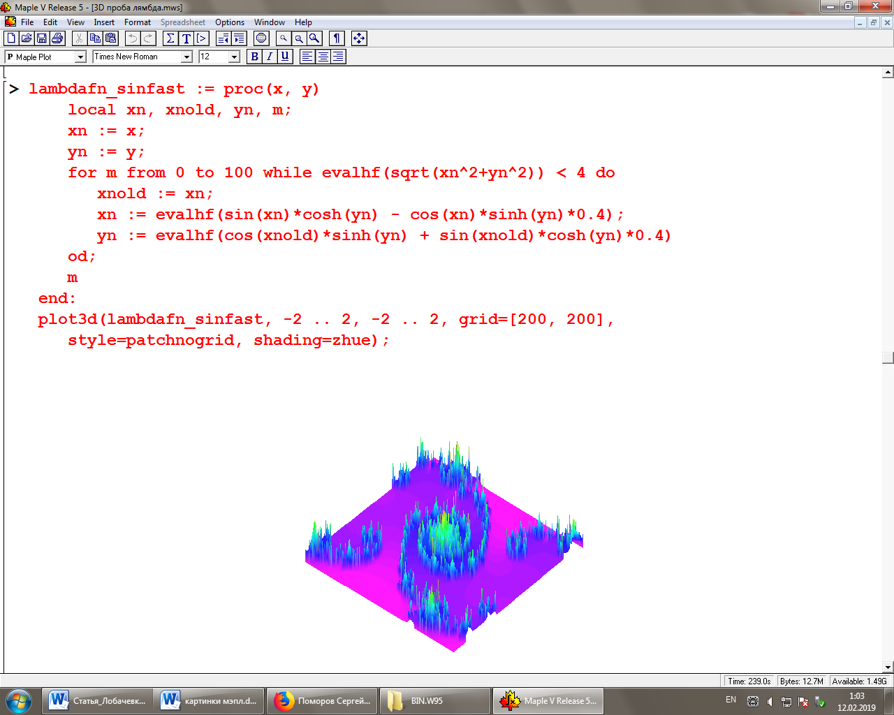
Serpinskiy’s triangle
i=0  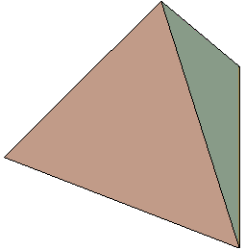 |  | i=1  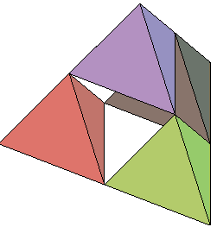 |  |  | i=4  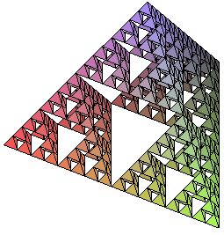
The Koch snowflake
i=0  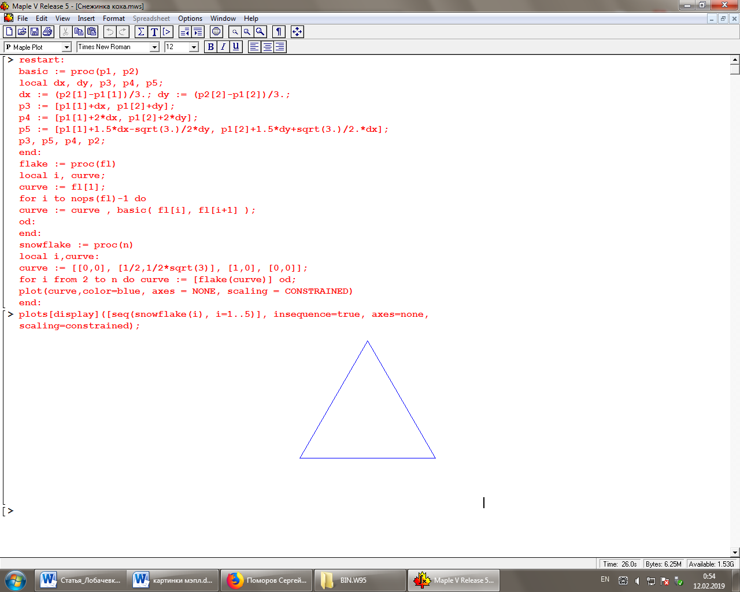 |  | i=1  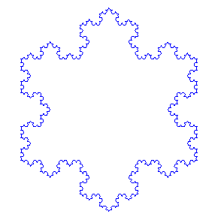 |  |  | 3-D  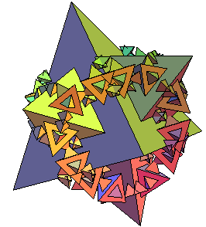
Mandelbrot set
For m from 0 to 30 while abs (z) < 2 do  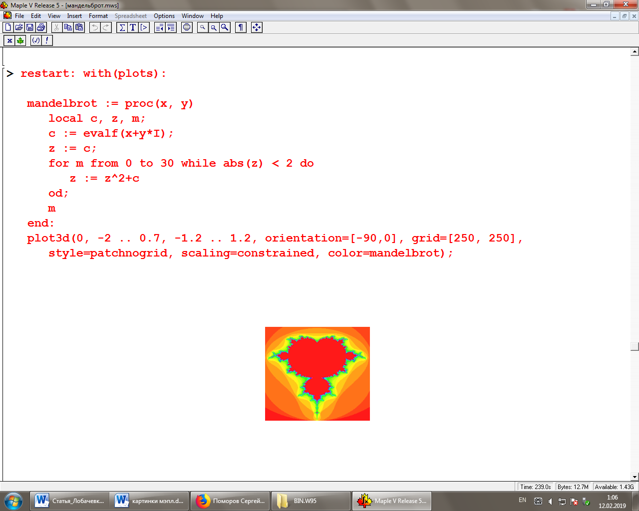 |  | to 30 while abs (z) < 4 do  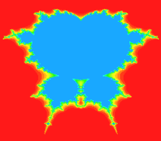 |  |  | 3-D  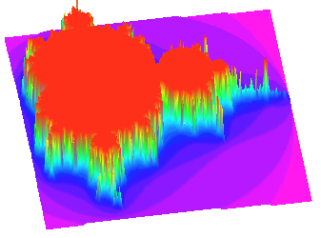
Newton’s swimming pools
2-D  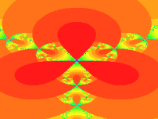 |  |  | 3-D  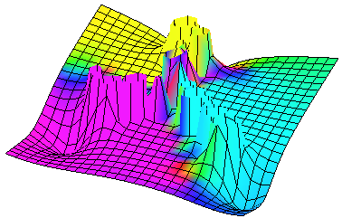

Conclusion
Scientists and philosophers argue, can we talk about universality of fractals in recent years. There are two groups of two opposite positions. We agree with the fact that fractals are universal. Due to the fact that movement is inherent property of material also we always have fractals wherever we have movement.
We are convinced that fractal is genetic property of the Universe, but it is not mean that all the Universe elements to the one fractal organization. In deployment process fractal structure is undergoing a lot of fluctuations (deviations) and a lot of points of bifurcation (branching) lead grate number of fractal development varieties.
Therefore, we think that fractals are general academic method of real world researching. Fractals give the methodology of nature and community researching.
In transitional, chaotic period of society development social life become harder. Different social systems clash. Ancient values are exchanged for new values literally in all spaces. So it’s vitally important for science to develop behavior strategies which allow to avoid tragic mistakes. We think that fractals play important role in developing of such technologies. And – synergy is theory of evolving systems self- organization. But evolution happens on fractal principles, as we know now.

