(4) | $ϕ_{n}\left(ζ_{n}\right)=\sum_{i=0}^{m}{a_{i}}Υ^{i}\left(ζ\right)+\sum_{i=1}^{m}{b_{i}}Υ^{-i}\left(ζ\right),$

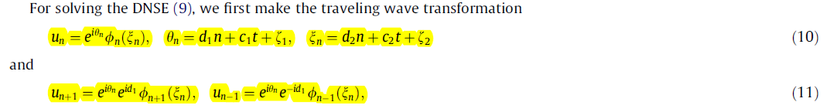
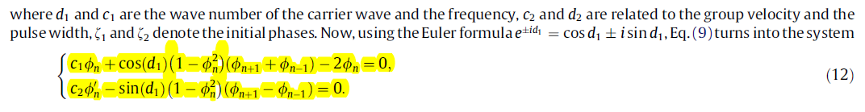
(13) | $ϕ_{n}\left(ζ_{n}\right)=a_{0}+a_{1}Υ\left(ζ_{n}\right)+\frac{b_{1}}{Υ\left(ζ_{n}\right)},$
 | where
(14) | $Υ\left(ζ_{n}\right)=\frac{p_{1}e^{q_{1}ζ_{n}}+p_{2}e^{q_{2}ζ_{n}}}{p_{3}e^{q_{3}ζ_{n}}+p_{4}e^{q_{4}ζ_{n}}},$

(15)
(16)
# We assume p = [−1, 1, 1, 1] and q =[1,−1, 1,−1], and so expression (14) turns to
(17) | $Υ\left(ζ_{n}\right)=-\frac{sinh\left(ζ_{n}\right)}{cosh\left(ζ_{n}\right)}=-tanh\left(ζ_{n}\right),$

(18) | $ϕ_{n+1}\left(ζ_{n+1}\right)=a_{0}+a_{1}Υ\left(ζ_{n}+g\right)+\frac{b_{1}}{Υ\left(ζ_{n}+g\right)},$
(19) | $ϕ_{n-1}\left(ζ_{n-1}\right)=a_{0}+a_{1}Υ\left(ζ_{n}-g\right)+\frac{b_{1}}{Υ\left(ζ_{n}-g\right)},$

Equations 17, 18 and 19 are placed in 15 and 16.
And then I think they will be simplified with the following commands:
simplify(eq01); fin1 := simplify(numer(%));
simplify(eq02); fin2 := simplify(numer(%));
subs(tanh(xi[n]) = Psi, fin1); fin3 := simplify(%);

subs(tanh(xi[n]) = Psi, fin2); fin4 := simplify(%);
for i from 0 to degree(fin3, Psi) do
EQ[i] := simplify(coeff(fin3, Psi, i));
end do;

